Net2 - Reconnect Door Controllers

Open - Net2 Configuration Utility
Login using system engineer
Click TCP/IP Nodes
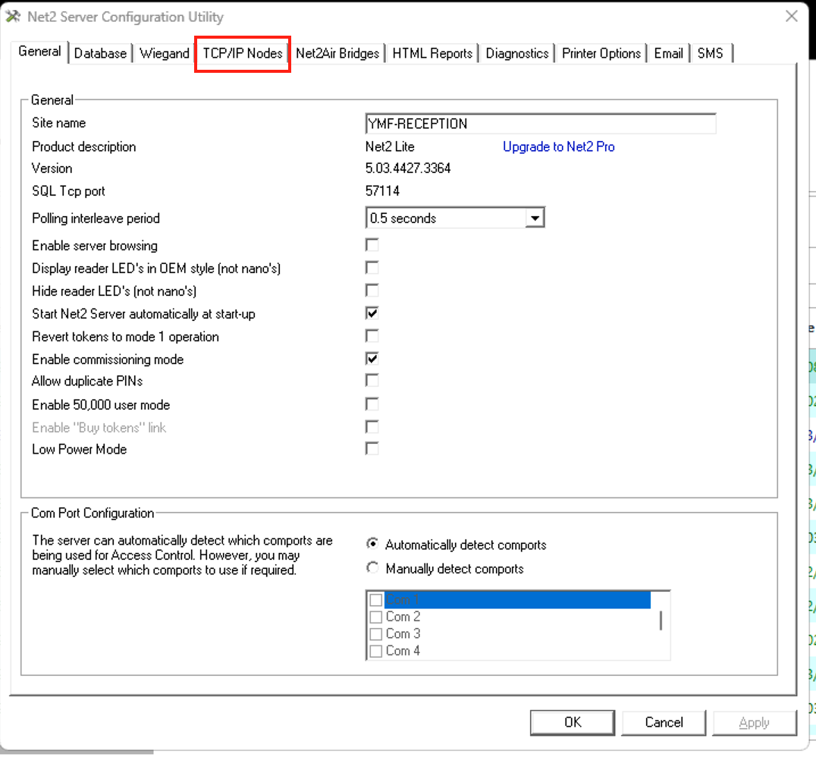

Click Detect then click Apply then click OK
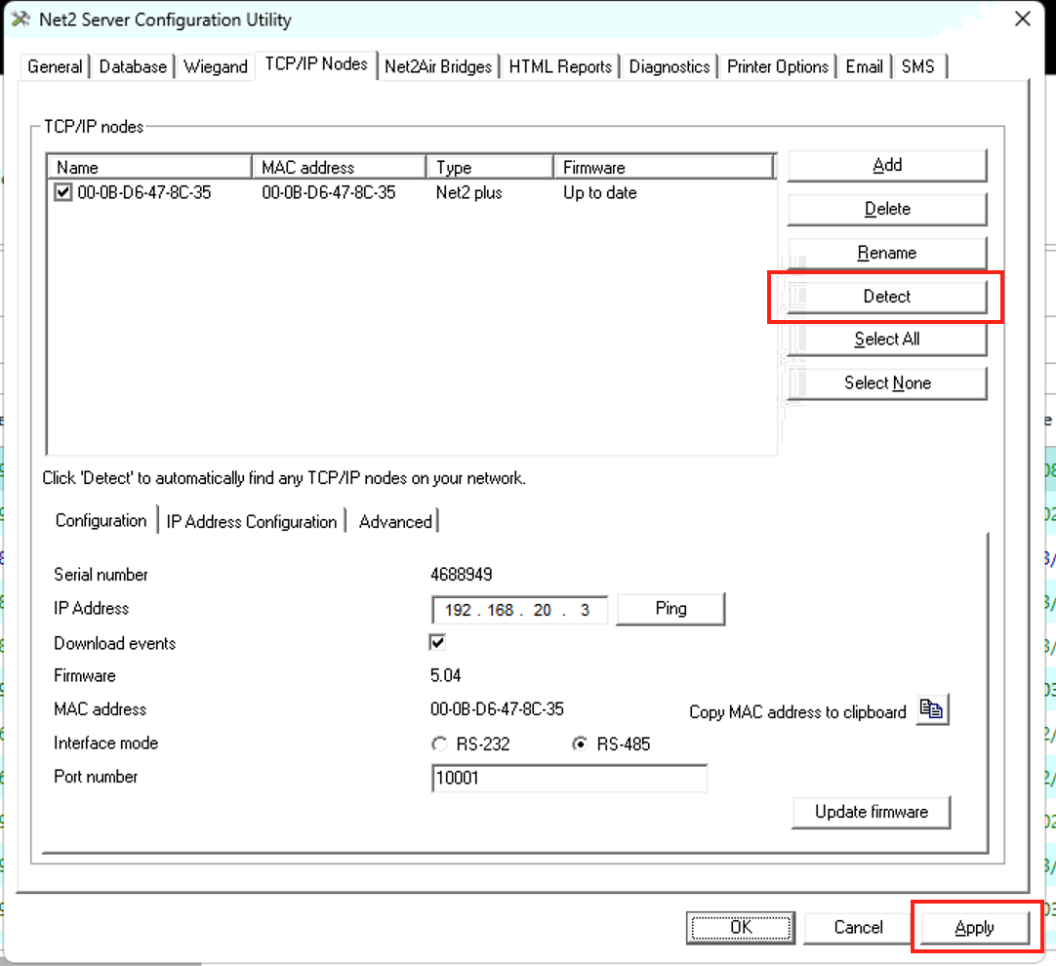
Click Yes to restart Server
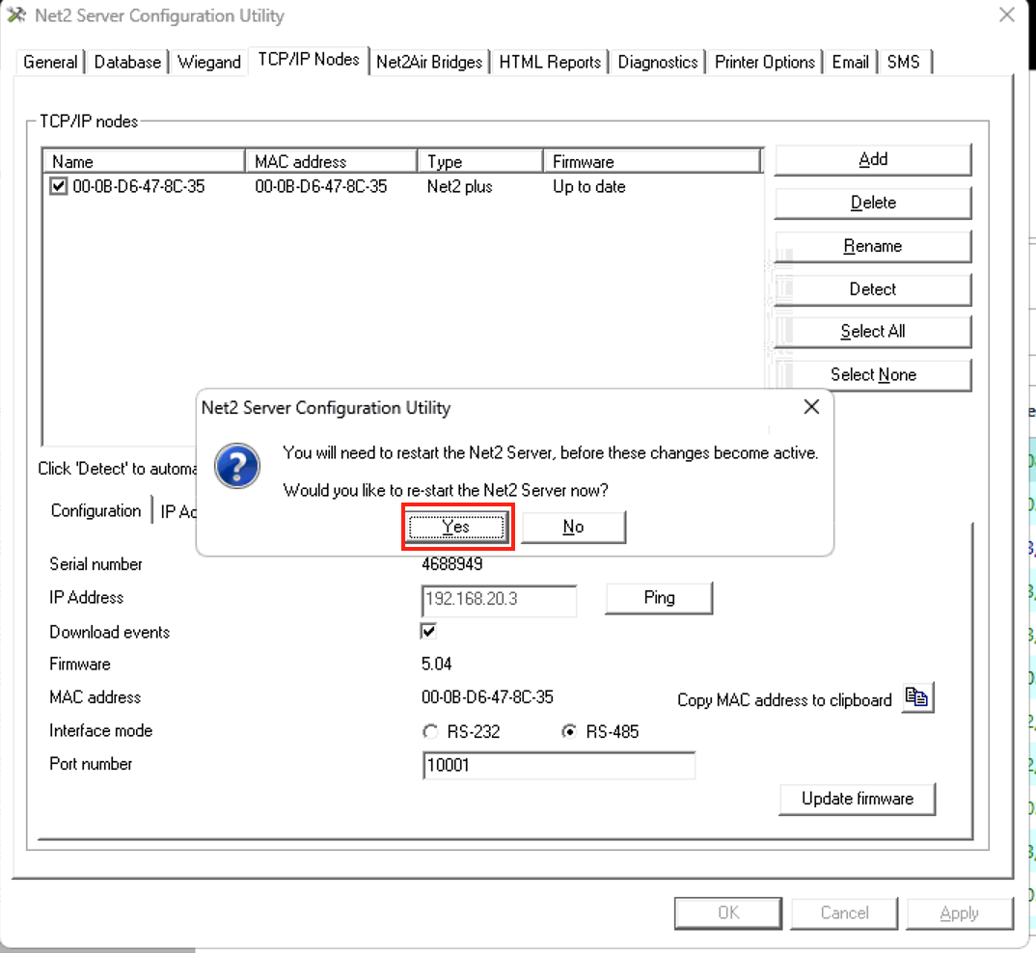

Now Open Net2 Software and login
Click Doors
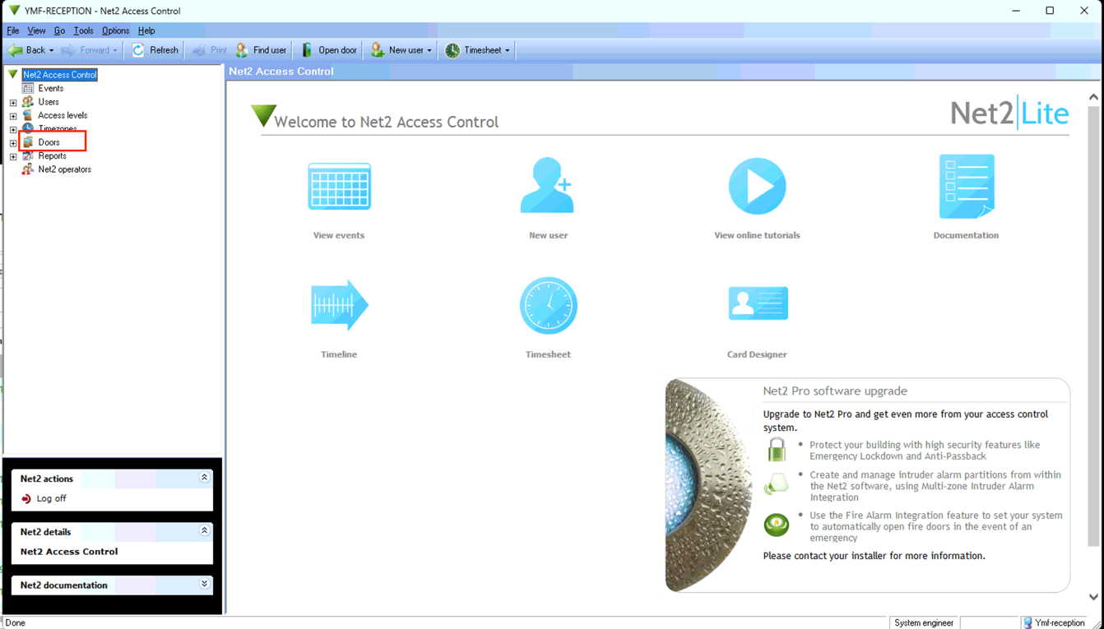

Doors should show the Green Tick